FOUNDATION UNIVERSITY ISLAMABAD
SCHOOL OF SCIENCE AND TECHNOLOGY

NAME: ALISHBA HAFEEZ
SUBJECT: PF(programming fundamentals)
SECTION: 25(B)
DEPARTMENT: BS IET
ROLL NO: 056
FORM NO: 1025234338
INSTRUCTOR: Mr. SHAMSHAIR

LAB MANUAL # 08

TASK 8.1:
Write a C++ program using function overloading. The name of the overloaded function is ‘square’. The different prototypes of this overloaded function are;
● void square(void);// Used to print a solid square of *s with side length of 5
● void square (char);// Used to print a solid square of the character passed as argument with side length of 6
● void square(char, int);// Used to print a solid square of the character and the side length passed as arguments to this function Make calls to these functions one by one in your program.

CODE:
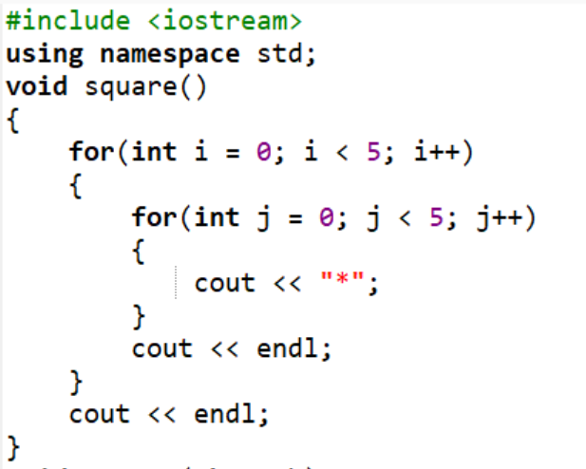
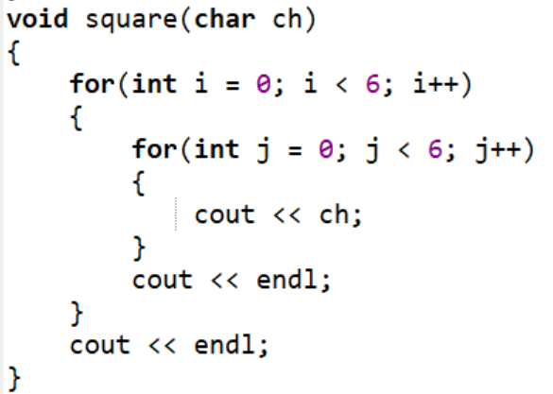
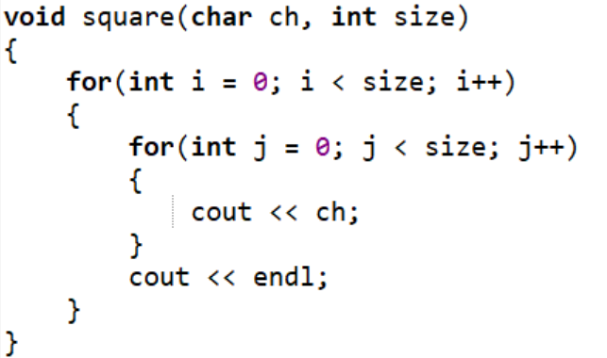
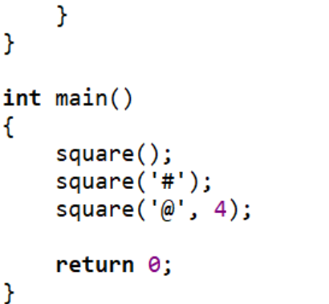

OUTPUT:
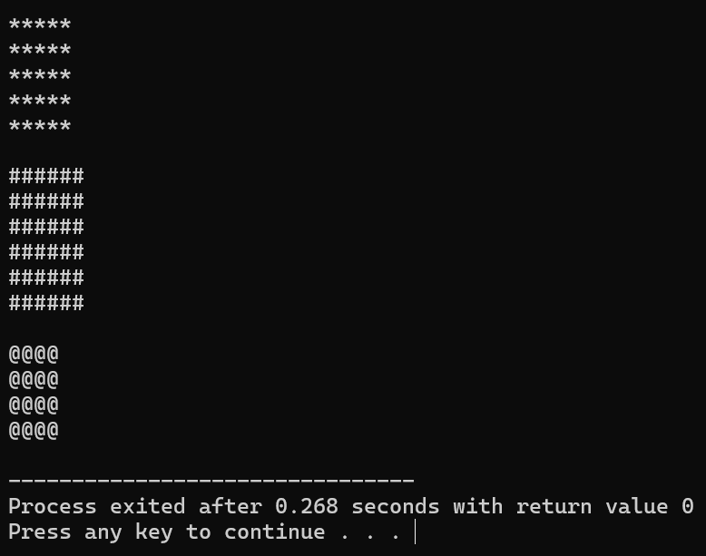

TASK 8.2:
Write a function ‘swap’ in C++ language that swaps the values of two variables passed as arguments to this function. Write a C++ program which takes values of two integer variables from the user and swaps their values using function ‘swap’. Your program should have the following interface.

CODE:
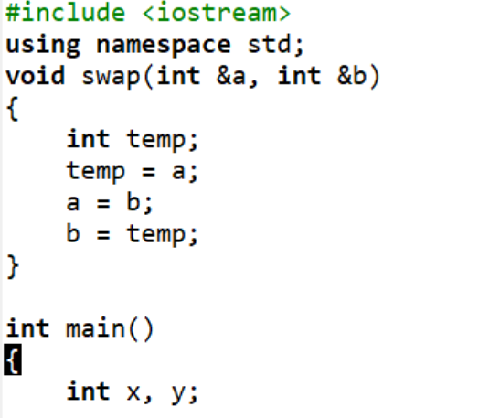
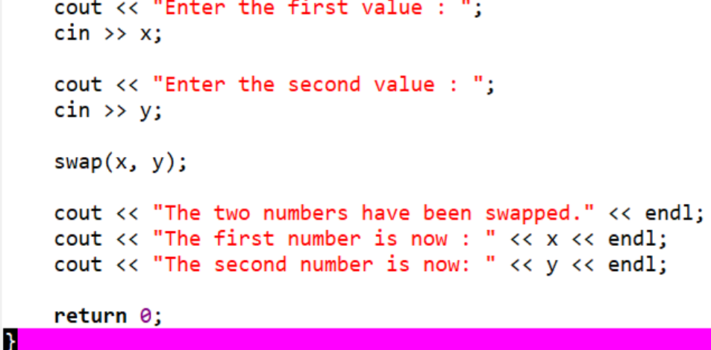

OUTPUT:
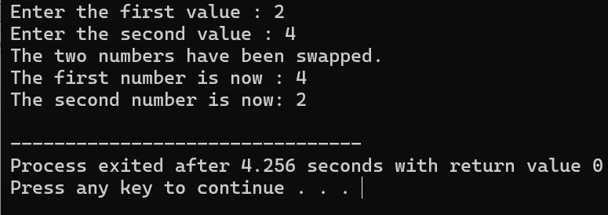

TASK 8.3:
Explain the following code and show the output.
CODE:
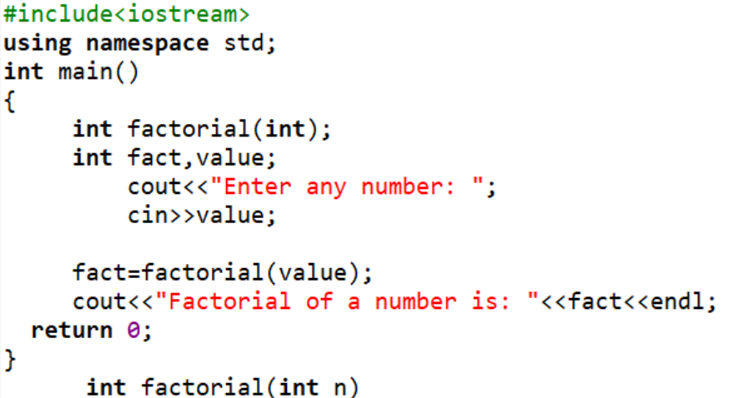
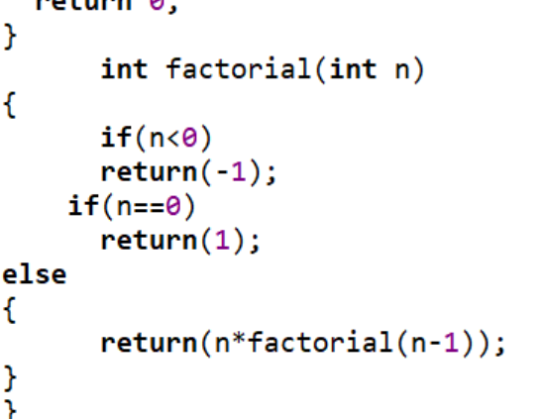

OUTPUT:
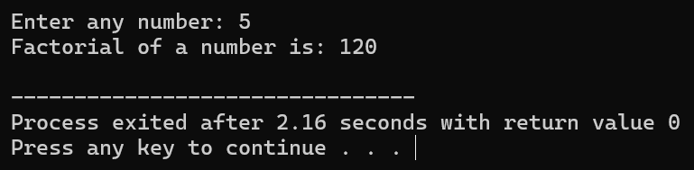

EXERCISE 8.1:
Write a C++ program using function overloading to calculate absolute values of float and int in two functions. (Hint: absolute values of |5| = 5 and |-5|= 5) Make calls to these functions one by one in your program.

CODE:
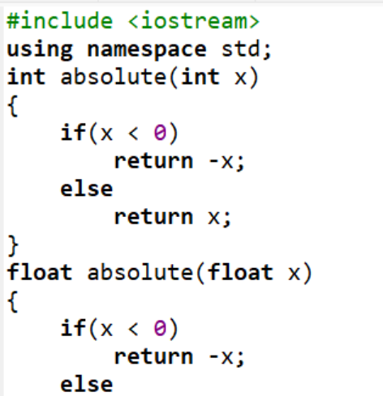
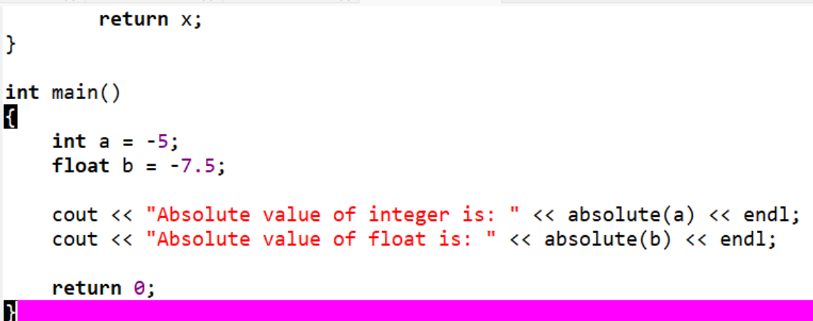

OUTPUT:
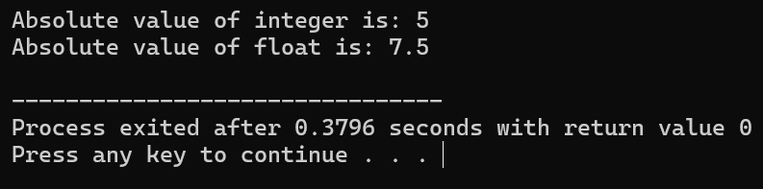

EXERCISE 8.2:
Define a recursive function named ‘generate numbers’ which takes single parameters named n and displays the series of numbers from 1 to N.

CODE:
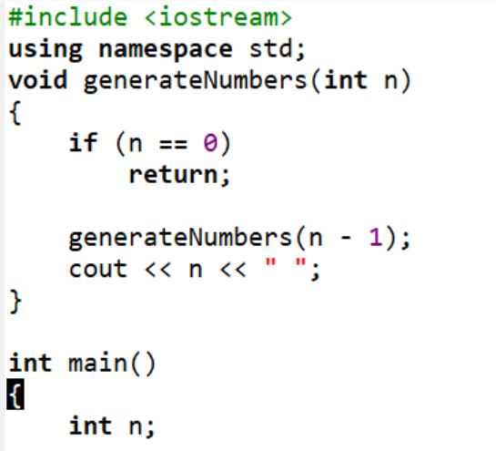
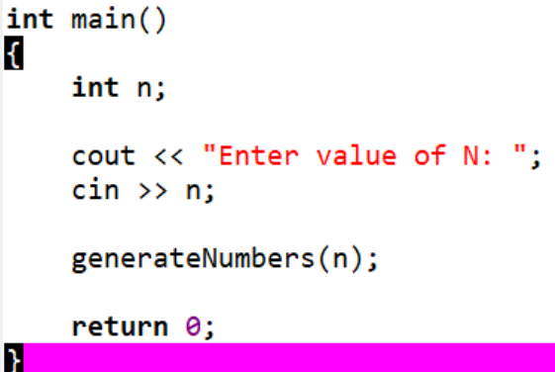

OUTPUT:
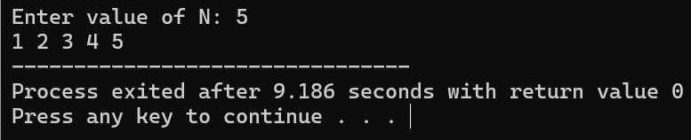

EXERCISE 8.3:
Define a recursive function named ‘power’ which takes two parameters, base and exponent, and returns the value equivalent to base multiplied by itself, exponent times.

CODE:
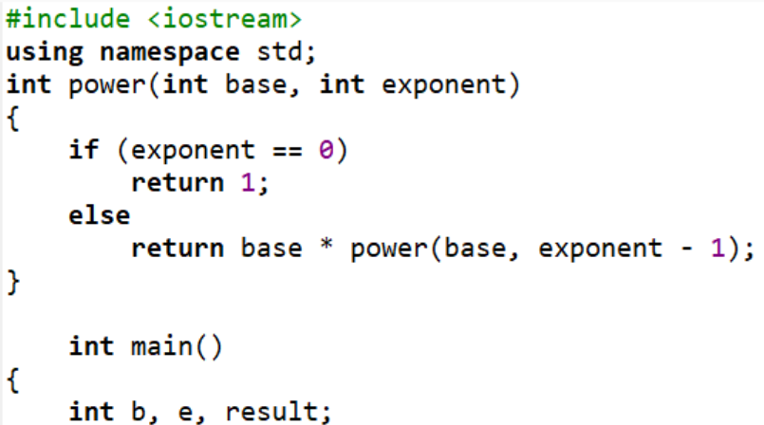
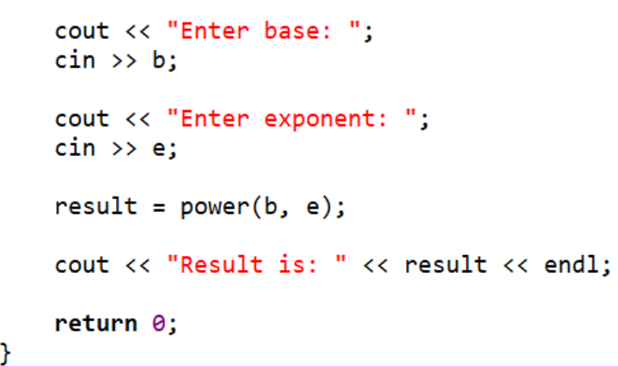

OUTPUT:
